Scene 1 details

Picture is a great example of a historically accurate scene for the 1824 election

* Outside social gathering
* Only white men
* Good ratio of tophat-level wealthy and more humble looking land owners
* Little to no political banners or affiliations. In 1824, there were few enough people that they knew who they and everyone else would be voting for a while before the election (or just didn’t care)
* There would’ve been a bit more in the way of food and drink at these events, especially in the southern states.

Character creation questionnaire:

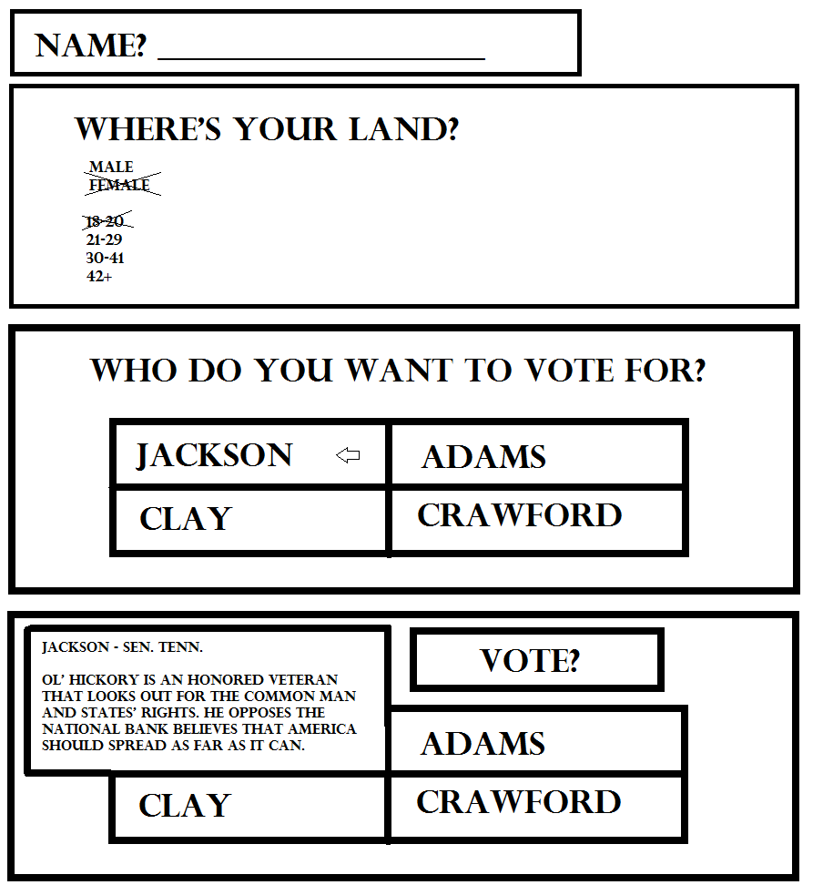

After answering the questions, the student can either vote or converse with the other voters before clicking on the clerk again to vote

When attempting to vote, the student will see a short bio of each candidate to help them decide their vote:

Jackson – Sen. Tenn. – Ol’ Hickory is a decorated war veteran that looks out for the common man and states’ rights. He opposes the idea of a national bank and believes that America should spread as far as it can

Clay – Speaker of the House – Henry Clay has demonstrated political brilliance with his work on the Missouri Compromise. He shows favor toward economic growth through manufacturing, an idea that the common farmer has come to hate.

John Quincy Adams – Sec. of State – The son of a founding father and president, John Quincy Adams hopes to drive America’s economy with education and modernization.

William H. Crawford – Sec. of Treasury – Crawford is the official nomination by the Democratic - Republican Party. He has a history of success in the positions of Secretary of War, Foreign Minister to France, Secretary of Treasury, Georgia senator, and acting vice president after the death of George Washington.

Nothing important happened until the votes were tallied which took a couple of months. We can either flash forward or add some story stuff here.